

2021-2022

High Ability Committee

Jackie Skaggs - High Ability Coordinator

Tammy Tiede, High Ability Teacher (K-5) – Hamilton and Bailey

Emily Coyle, Teacher - Hamilton

Stephanie Compton, Teacher - Bailey

Karen Reynolds, Teacher- Edison Jr. Sr. High TBD

Karen Curtis, School Board Member TBD

Camryn Liners, Teacher - Hamilton

Jennifer Havens-Rodriguez. Principal- Hamilton

Terry Kolopanis, Principal- Bailey

Christine Pepa, Principal- Edison Jr. Sr. High School

**Lake Station Community Schools**

**High Ability Handbook**

**High Ability Program**

**Parent/Student Handbook**

**Lake Station Community Schools**

**September 2021**

The Purpose of this handbook is (1) to define and describe the Lake Station Community Schools High Ability Program, its on-going development and implementation, and (2) to provide general information about high ability students, instructional strategies and program options. Revisions will occur as teachers, students, parents, administrators, and other key stakeholders interact and react to the program and curriculum.

**Contact Persons**

**Mrs. Jackie Skaggs**

High Ability Program Coordinator

Lake Station Community Schools

3304 Parkside Ave.

Lake Station, In 46405

219-962-8531 ext. 4604

**Ms. Tammy Tiede**

High Ability Teacher (K=5)

Bailey and Hamilton Elementary

ttiede@lakes.k12.in.us

**Ms. Jennifer Havens-Rodriguez**

Administrator Contact

Alexander Hamilton Elementary School

2900 Lake St.

Lake Station, In 46405

219-962-1824

**Mr. Terry Kolopanis**

Administrator Contact

Virgil I. Bailey Elementary School

2100 Union St.

Lake Station, In 46405

219-962-1302

**Ms. Christine Pepa**

Administrator Contact

Thomas A. Edison Jr. Sr. High School

3304 Parkside Ave.

Lake Station, In 46405

219-962-8531

**Table of Contents**

Definition……………………………………………………………………………………………………

Lake Station Mission Statement………………………………………………………………….

High Ability Philosophy/Mission Statement……………………………………………….

The Broad-Based Planning Committee (BBPC)……………………………………………..

High Ability Identification Process………………………………………………………………

Curriculum………………………………………………………………………………………………….

High Ability versus High Achievers………………………………………………………………

Appeal Process……………………………………………………………………………………………

Exiting the Program………………………………………………………………………………………

Resources for Parents…………………………………………………………………………………..

Counseling & Guiding the High Ability Student…………………………………………….

Resources for Parents…………………………………………………………………………………

Glossary………………………………………………………………………………………………………

Appendix …..Exit Form

**Definition of High ability**

Pursuant to Indiana Code 20-36-1, a high ability student is a student who: (1) performs at or shows the potential for performing at an outstanding level of accomplishment in at least one domain when compared with other students of the same age, experience, or environment; and (2) is characterized by exceptional gifts, talents, motivation, or interests. (Please note that in Indiana, the terms “gifted” and “high ability” are used interchangeably.)

**Lake Station Community Schools Mission Statement**

### **The mission of the Lake Station Community Schools, in cooperation with parents and the community, is to provide quality learning opportunities enabling all students to reach their potential. We are dedicated to providing a safe, nurturing environment which fosters the development of students who will make sound decisions in an ever- changing world.**

**High Ability Mission Statement**

The Lake Station Community Schools recognize that some students perform at, or show the potential to perform at, an exceptional level of accomplishment in the core academic areas of language arts and/or mathematics. These students are found in all socio-economic, cultural, and ethnic backgrounds. We are dedicated to providing a safe, nurturing environment which fosters the 21st Century Skills of communication, critical thinking, problem solving, collaboration and creativity. It is the responsibility of the Lake Station Community Schools to cultivate, nurture, and develop these talents in their high ability learners.

**Program Goals**

The High Ability program will:

* Be developed, evaluated, and improved with input from students, staff, parents, and other community members.
* Identify high ability learners regardless of gender, race, age, or socio-economic background.
* Provide challenging differentiated curriculum and instruction that corresponds with the ability and achievement levels of the high ability learners.
* Provide training to all staff and stakeholders in the academic, social, and emotional needs of the high ability learners.

**Program Services**

**Grades K-5**

Lake Station Community Schools will serve elementary high ability students through the School-wide Cluster Grouping Model (SCGM). High Ability Learners will be placed in cluster groups at individual grade levels.  The number of cluster groups will vary depending on the number of High Ability students in the grade level. The teacher will [differentiate the curriculum](http://www.wclark.k12.in.us/uploads/file/Christina%20Pearson/DIFFERENTIATED%20EDUCATION%20PLAN%20FOR%20IDENTIFIED%20HIGH%20ABILITY%20STUDENTS%20IN%20GRADES%20K.pdf) for the High Ability Learners by using various strategies, such as, but not limited to: curriculum compacting, tiered lessons, ability grouping, flexible grouping, acceleration, and independent study projects. The High Ability Teacher will serve as a resource to the cluster teachers, as needed. Cross-grade and between-class grouping will also be used when grade level numbers do not allow for the utilization of Cluster Grouping. Elementary High Ability Students will also be pulled out of the regular classroom twice a week to work with the High Ability Teacher.

**Grades 6-8**

High Ability learners entering Jr. high are looked at individually to determine the best class placement for these students depending on their academic strengths and interests. Please contact the school’s counselor for additional information on course offerings. High Ability learners may also be clustered into a classroom where the teachers will differentiate the curriculum for the High Ability learners by using various strategies, such as, but not limited to: curriculum compacting, tiered lessons, ability grouping, flexible grouping, acceleration, and independent study projects. The High Ability Coordinator will serve as a resource to the cluster teachers, as needed.

**Grades 9-12**

High Ability learners entering high school are also looked at individually to determine the best class placement. High Ability learners are encouraged to take Advanced Placement courses and Dual Credit courses. Please contact the school’s counselor for additional information on course offerings.

Weighted courses and their equivalence. (Found in the Edison Course handbook)

**WEIGHTED COURSES**

Quality (or bonus) points are awarded to a student who successfully completes an accelerated class. Such points are figured into the student's grade point average and class rank.

Ex: A grade of "A" normally is worth 4.00 quality points

An Honors class with the same grade would receive 4.50 quality points.

An AP or Dual Credit class with the same grade would receive 5.00 quality points.

**COLLEGE COURSES FOR HIGH SCHOOL CREDIT**

Qualified juniors and seniors are allowed to enroll in college courses, which allow credit to be granted toward both high school and college graduation. Students participating in this program must follow certain procedures. Interested students must meet with their counselor for details.

**High Ability Identification Process**

**General Information**

* Student potential manifests itself at different times in early grades.
* Multiple opportunities for identification in grades K-2 exist to meet primary students’ varying development.
* Students may be identified as having High Academic performance or potential in math, language arts, or both.
* A High Ability designation remains in place unless subsequent tests and/or classroom performance does not support continuation. Students who fall in this category will be given interventions, for at least three weeks, to keep them in the program. If, after interventions put in place are not successful, a case conference with all stakeholders will take place. At that time, a determination will be made regarding placement.
* Parent(s)/Guardian(s) have the right to appeal the determination.

Students in grades k, 2 and 5 will be screened using the CogAT Screener. K students who show advanced learning will be pulled out to work with the High Ability Teacher. Students in grades 2 and 5 who show advanced potential will be given the Post Screener within 30 days of screening.

Students in K and 1 who show advanced potential on the CogAT Screener (score of 7,8. or 9) and/or the NWEA Test will be pulled out to work with the High Ability Teacher twice a week. They will be rescreened in 2nd grade to see if they qualify for continued services.

Students in 2-5 who show advanced potential on the NWEA Test (80 percentile or higher) will either be further tested with the CogAT Post Screener or the CogAT full battery for grades that do not take the CogAT screener. Any student who perform at the 94% or higher will automatically qualify for the program.

**High Ability Qualifications information**

|  |  |  |
| --- | --- | --- |
| **Grade Level** | **Language Arts** | **Math** |
| **Kindergarten/First Grade** | **1. Score of 7, 8 or 9 on CogAT Verbal Screener**  **2.Teacher Recommendation 3. 90th percentile and above on NWEA Reading** | **1.Score of 8 or 9 on CogAT Quantitative or Nonverbal Screener**  **2.Teacher Recommendation**  **3. 90th percentile and above on NWEA Math** |
| **Second through Fifth must meet two of these qualifiers** | **1.Score of 7, 8 or 9 on CogAT Verbal Screener**  **2.Teacher Recommendation**  **3. 90th percentile and above on NWEA Reading**  **4. Any student who scores at the 94th Percentile of above automatically qualifies as High Ability**  **5. Pass+ on iLearn Reading/Language Arts** | **1.Score of 8 or 9 on CogAT Quantitative or Nonverbal Screener**  **2.Teacher Recommendation**  **3. 90th percentile and above on NWEA Math**  **4. Any student who scores at the 94th Percentile of above automatically qualifies as High Ability**  **5. Pass+ on iLearn Math** |
| **Sixth through Eighth – Students must meet 2 qualifiers** | **1.Score of 7, 8 or 9 on CogAT Verbal Screener**  **2.Teacher Recommendation**  **3. 90th percentile and above on NWEA Reading**  **4. Any student who scores at the 94th Percentile of above automatically qualifies automatically as High Ability**  **5. Pass+ on iLearn Reading/Language Arts** | **1.Score of 8 or 9 on CogAT Quantitative or Nonverbal Screener**  **2.Teacher Recommendation**  **3. 90th percentile and above on NWEA Math**  **4. Any student who scores at the 94th Percentile of above automatically qualifies as High Ability**  **5. Pass+ on iLearn Math** |

**Grades 9-12**

High school students new to the district may be given NWEA Reading and Math and/or (in the 10th and 11th grade) the PSAT for screening/identification purposes.

**Identification Committee**

A selection team comprised of a Broad-Based Planning Committee, teachers and administrator members reviews all assessments and identifies students according to the district’s selection criteria, shown in the table above. If the selection team feels there is conflicting evidence regarding student ability and/or potential, they may request additional information and/or discuss the case with the district’s High Ability Program Coordinator. The selection team makes the final eligibility determination.

**CONTINUED PLACEMENT**

* A student **who qualifies for High Ability placement in Kindergarten** will be placed in the program for grades 1 & 2.  While in 2nd grade, students will participate in the screening process again and must “re-qualify” to remain in the program.  This is necessary because learned reasoning ability and achievement scores can change rapidly in the primary grades.  Therefore, it's important to make sure that students who qualified in Kindergarten are still performing up to the same standard, when compared to their same-aged peers at the end of second grade.
* **A student who is identified at the end of 2nd grade** will remain in the program unless a student begins to perform poorly in the program or on subsequent tests and the Exit Procedures (described below) are initiated by a teacher or parent.

**Student Probation / Withdrawal / Exiting**

The State of Indiana requires school districts to show a minimum of one year’s academic growth for each identified high ability student each school year. If a high ability student is struggling and/or not achieving at his/her expected level of performance, phone calls, parent-teacher conferences or written communications will be used to resolve any issues or concerns of the parent, student or teacher. Students may be put on probation while interventions are sought to keep the student in the program. If the situation persists, then a formal conference will be scheduled. All issues should be examined and resolution(s) sought.

A child may be placed on three-week probation. At the end of the probation period, the parents, student, teacher and principal will meet to discuss placement status. If either the school or the parent decides to exit or withdraw the student from the program, an Exit Request form (found in the Appendix) should be completed and sent to the district’s High Ability Program Coordinator for approval.

**PETITIONING/APPEALS PROCEDURES**

* If parents do not agree with the selection team’s decision, they can write an appeal to the district’s High Ability Coordinator (Form found in Appendix).
* Within one week of receiving the appeal, the High Ability Coordinator will contact the parents to schedule a meeting. During the meeting, parents will be asked to present any additional evidence, such as portfolio materials or outside testing results (at the parent’s expense). The High Ability Coordinator will ask questions that will help in the decision-making and present any relevant data.

After the meeting, the High Ability Committee will review the original data collected and the newly presented evidence to decide. Parents will be notified of the decision by mail within 10 school days of the meeting.

**High Achiever Vs. Gifted Student**

Although the terms are often confused, there are distinct differences between a gifted learner and high achiever. ***A gifted learner may or may not be a high achiever. Likewise, a high achiever may or may not be gifted.*** High achievers are those students that perform well in school, while gifted students are those that have high intelligence and a propensity for learning. When trying to determine whether a student is gifted and/or high achieving, there are a number of traits and behaviors to consider.

**1.**     **High Achievers**

High achievers are students that have a strong motivation to perform well and succeed in school. These types of students usually enjoy school, get A's, memorize information easily, give complete and accurate answers, have advanced knowledge and are at the top of their class. They tend to be satisfied with their knowledge and skills, and will receive new information with willingness and interest when required. High achievers are usually emotionally and socially on track, and they relate well to peers of their own age.

**2.**     **Gifted Learners**

Gifted learners are students that have a strong motivation to learn and expand their intellectual capacity. They prefer self-directed learning, may or may not be motivated by grades, are excellent at making inferences and connections, pose complex questions, generate abstract concepts and are beyond their class. They are not satisfied with a straightforward answer, preferring to examine a problem's intricacies and underlying implications. They tend to be self-critical and are constantly seeking to expand their knowledge. Gifted learners may be emotionally and socially behind, on track or advanced. Most tend to connect with peers on the basis of shared intellectual interest rather than similarity in age.

**3.**     **Gifted and High Achieving**

Although high achieving and gifted are two separate descriptors, this does not mean that they cannot occur together. Some students are both high-achieving and gifted learners. These students tend to do very well in school, receiving high grades and performing well on homework and exams. At the same time, they approach problems with innovation and complex reflection. Although their primary motivation is to learn, this desire tends to lend itself naturally toward strong performance and high achievement.

**4.**     **Gifted but Not High Achieving**

Some students are gifted, but not necessarily high achieving. In these instances, the student is usually unable to perform well because he is not stimulated by the simplicity of the lesson or too distracted by his own abstract thoughts to demonstrate competency in tests or homework. Totally unmotivated by grades, this type of student thrives on intellectual challenge. Advanced courses, less structured (but more difficult) homework assignments and essay style exams often improve their academic performance.

**5.**        **High Achieving but Not Gifted**

Students that are high achieving but not necessarily gifted excel in almost any classroom setting. Since they are motivated strongly by grades, they benefit from strict grading standards that force them to expand their abilities. They learn well by memorizing and prefer straightforward problems and answers. They will become frustrated if given a problem that is too vague or abstract with no solid answer.

 In 1989, Janice Szabos published a comparison of the bright child and the gifted learner. Her comparison helps to delineate differences between the two groups and provides a useful format for discussions. However, some of the items listed in the comparison are questionable. For example, the gifted learner is credited with having wild, silly ideas. In reality, it is creative thinkers who exhibit the ideas often called wild or silly; not all gifted learners demonstrate that aspect of the creative process. Responding to those concerns, a three-way comparison of a high achiever, a gifted learner, and a creative thinker is proposed for you to consider and ponder. No column is intended to be mutually exclusive. For example, a high achiever might also be a creative thinker, and a gifted learner might also be a creative thinker; a creative thinker might also be a high achiever, and a gifted learner might also be a high achiever.

**A High Achiever...                       A Gifted Learner...               A Creative Thinker...**

|  |  |  |
| --- | --- | --- |
| Remembers the answers. | Poses unforeseen questions. | Sees exceptions. |
| Is interested. | Is curious. | Wonders. |
| Is attentive. | Is selectively mentally engaged. | Daydreams; may seem off task. |
| Generates advanced ideas. | Generates complex, abstract ideas. | Overflows with ideas, many of which will never be developed. |
| Works hard to achieve. | Knows without working hard. | Plays with ideas and concepts. |
| Answer the questions in detail. | Ponders with depth and multiple perspectives. | Injects new possibilities. |
| Performs at the top of the group. | Is beyond the group. | Is in own group. |
| Responds with interest and opinions. | Exhibits feelings and opinions from multiple perspectives. | Shares bizarre, sometimes conflicting opinions. |
| Learns with ease. | Already knows. | Questions: What if... |
| Needs 6 to 8 repetitions to master. | Needs 1 to 3 repetitions to master. | Questions the need for mastery. |
| Comprehends at a high level. | Comprehends in-depth, complex ideas. | Overflows with ideas--many of which will never be developed. |
| Enjoys the company of age peers. | Prefers the company of intellectual peers. | Prefers the company of creative peers but often works alone. |
| Understands complex, abstract humor. | Creates complex, abstract humor. | Relishes wild, off-the-wall humor. |
| Grasps the meaning. | Infers and connects concepts. | Makes mental leaps: Aha! |
| Completes assignments on time. | Initiates projects and extensions of assignments. | Initiates more projects that will ever be completed. |
| Is receptive. | Is intense. | Is independent and unconventional. |
| Is accurate and complete. | Is original and continually developing. | Is original and continually developing. |
| Enjoys school often. | Enjoys self-directed learning. | Enjoys creating. |
| Absorbs information. | Manipulates information. | Improvises. |
| Is a technician with expertise in a field. | Is an expert who abstracts beyond the field. | Is an inventor and idea generator. |
| Memorizes well. | Guesses and infers well. | Creates and brainstorms well. |
| Is highly alert and observant. | Anticipates and relates observations. | Is intuitive. |
| Is pleased with own learning. | Is self-critical. | Is never finished with possibilities. |
| Gets A's. | May not be motivated by grades. | May not be motivated by grades. |
| Is able. | Is intellectual. | Is idiosyncratic. |

Sources:

1.      <http://www.ehow.com/info_8747594_high-achiever-vs-gifted-student.html>

2.      Szabos, J. (1989). Bright child, gifted learner. Challenge, 34. Good Apple.

Guidance and Counseling

Students with high ability can often respond to socio-emotional issues differently than their peers. Guidance counselors understand the characteristics of high ability students, recognize their differing needs and provide services that meet their needs. They work in collaboration with teachers to meet the social and emotional needs of these students.

Guidance counselors provide classroom guidance lessons, small group counseling sessions, and individual guidance and counseling sessions for all students. Guidance lessons and counseling services are differentiated for high ability students depending on their needs. This includes but is not limited to college and career planning, course selection and individual personal counseling needs. The guidance and counseling department maintains resources for teachers, students and parents. Guidance counselors can also assist with a referral to outside services if the need dictates.

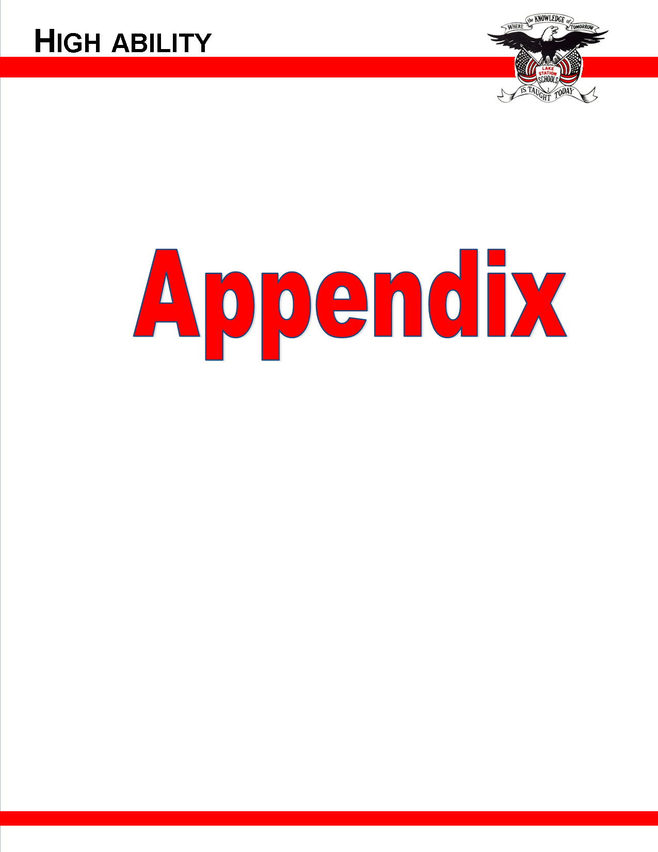



**High ability Parent Appeals Form**

## High Ability Office

## 3304 Parkside Ave.

## Lake Station, In 46405

## 219-962-8531 ext. 4604

## Student name:____________________________________________________

## Grade level and school:______________________________________________________________________________

## Parent(s) name:______________________________________________________________________________________

## Email address:________________________________________________________________________________________

## Phone number:________________________________________________________________________________________

## 

## Please know that the committee made their decision based upon valid data and upon what they believe would be the best placement for your child. If you do make an appeal, please support your appeal with information that you want the committee to consider. You may attach additional sheets or write on the back, if needed. Boredom, GPA, and grades on report card are not reasons for an appeal. If any outside testing has been done, please submit a copy of the testing report(s).

## 

## 

## 

## 

## 

## 

## Parent/Guardian Signature_____________________________________________Date___________________________

## 

## Please complete the Appeal Form and mail or deliver to the location listed above. A parent meeting will be scheduled.

## After the meeting, the High Ability Committee will review the original data collected and the newly presented evidence and make a decision. Parents will be notified of the decision by mail within 10 schools days of the meeting. **ALL DECISIONS ARE FINAL.**

## 

Parent Resources

Indiana Association for the Gifted

<http://www.iag-online.org/>

Indiana Department of Education High Ability Home Page

<http://www.doe.in.gov/exceptional/gt/welcome.html>

National Association for Gifted Children (NAGC)

[www.nagc.org](http://www.nagc.org)

Hoagies’ Gifted Education Page

<http://www.hoagiesgifted.org/>

Center for Gifted Studies and Talent Development, Ball State University

<http://cms.bsu.edu/Academics/CentersandInstitutes/GiftedStudies.aspx>

Parenting Gifted Children (Bertie Kingore, Ph.D.)

<http://www.bertiekingore.com/Kingore-CAG.pdf>

Differentiating Instruction: Rethinking Traditional Practices (Bertie Kingore, Ph.D.)

<http://www.bertiekingore.com/diffinstruct.htm>

Glossary of Terms

National Association for Gifted Children

<http://www.nagc.org/resources-publications/resources/glossary-terms>